Investment offer 1- plot

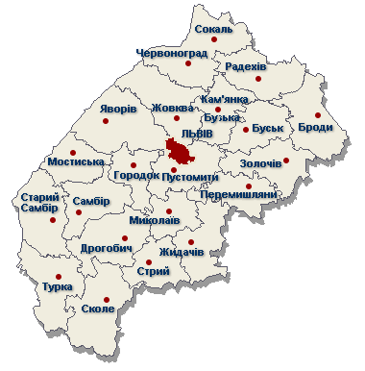 |  | 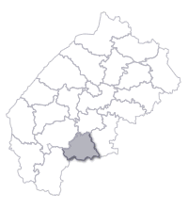
Address | Area | General information | Contact person
19 Skoliwska Street, Stryj | 35126 m² | Possibility of plot’s usage for bus servicing station or for gas station. The condition of the investment realization is sale, form of property - municipal, distance to the railway – 0,2 km, distance to Lvov – 75 km, distance to Kijów –Czop route – 0,1 km. | Lilia Hrećko – Manager of Land Resources in Stryj  +38 03245 5 23 62  +38 03245 5 90 19  vykonkom@stryi.lv.ukrtel.net

Investment offer 2- plot

 |  | 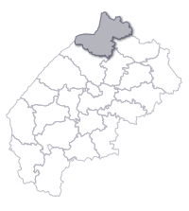
Address | Area | General information | Contact person
8 Bohdana Chelnyckogo Street, Czerwonograd | 2160 m² | Possibility of plot’s usage for building areas for materials warehousing, warehouses, garages, on this plot there is an orchard now. The condition of investment realization is a private form of property, distance to the railway – 0,35 km, distance to Lvov – 70 km, distance to Kijów – Rawa Ruska route - 50 km, (plot is located by the Lwów – Sokal road). | Ludmiła Stecyk –Director of the „Bakery of Czerwonograd” Joint-stock Company  +38 03249 2 54 41  +38 03245 2 13 74  chervonograd@hlibprom.com.ua

Investment offer 3- plot

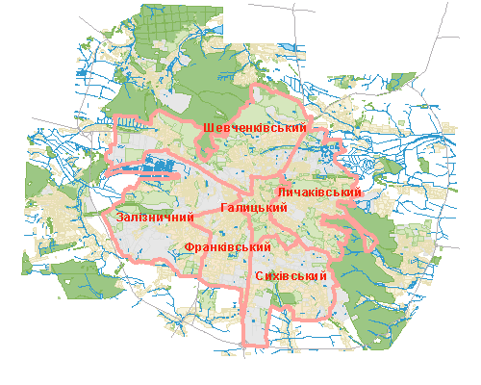
Address | Area | General information | Contact person
Truskawecka Street, Lvov | 8000 m² | Possibility of plot’s usage for a few floors garage, vehicles servicing station, gas station. The condition of the investment realization is sale or common usage, collective form of property, distance to railway – 0,5 km. | Wasyl Artym - Manager of Land Resources in Stryj  +38 0322 64 58 21

Investment offer 4- plot

 |  | 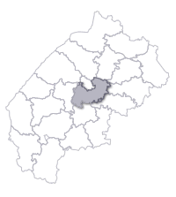
Address | Area | General information | Contact person
Murowane city, Pustomytiwski District | 12775 m² | Possibility of plot’s usage for industry sector. The condition of the investment realization is renting, private form of property, distance to Lvov – 11 km, distance to Kijów –Czop route – 0,2 km. | Orysja Semenjuk – Representative of the Close Joint-stock Company „Ukrainian Knitting Factory” (The factory is the owner of the land)  +38 032 241 34 41  +38 032 241 80 50  +38 032 240 44 60

Investment offer 5- plot

Address | Area | General information | Contact person
226a Kulparkiwska Street, Lvov | 10000 m² | Possibility of plot’s usage for trade rooms, production halls and offices buildings. The condition of the investment realization is sale, municipal form of property, distance to railway – 3 km, distance to Kijów –Czop route– 1 km. | Igor Gumenczuk – Vice Manager of the Natural Resources and Regulation of the Land Relationships Board  +38 032 295 57 21  +38 032 297 57 89

Investment offer 6- offices

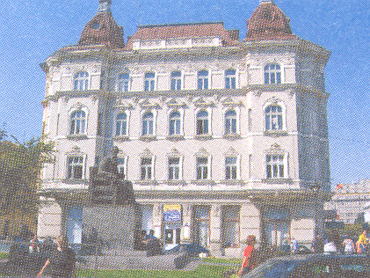
Address | Area | General information | Contact person
28 Prospekt Szewczenka, Lvov | 500 m² / second floor/ 360 m² / third floor/, 104 m² /forth floor | Possibility of usage for offices and flats. The condition of the investment is renting, private form of property. | Jurij Pawłuń - Owner +38 067 593 08 92

Investment offer 7- Żowkiwskij castle, north-western part of the building
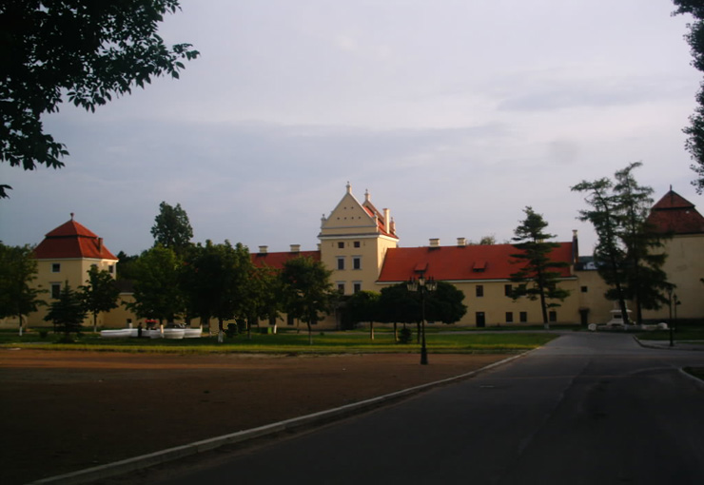 |  |  | 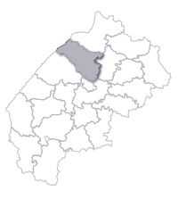
Address | Area | General information | Contact person
2 Wiczewa Square, Żowkwa | 1350 m² | Possibility of usage for hotels. The condition of the investment realization is renting for 25 years, state-owned form of property, distance to Lvov – 25 km, distance to Lvov – Warszawa route – 1 km. | Mychajło Kubaj – Director of the National Architectural – History Complex of the historic Żowkwa city.  +38 03252 2 25 49  +38 066 713 97 14

Investment offer 8- Joint-stock Company: „Shoes factory of Borysław”

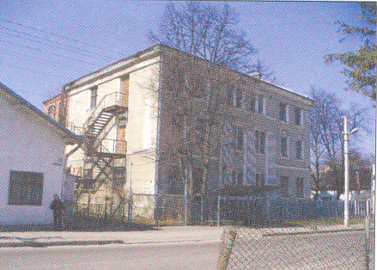 |  |  | 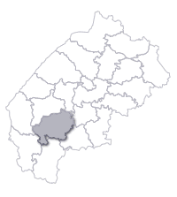
Address | Area | General information | Contact person
142 Szewczenka Street, Borysław | 4600 m² | Possibility of usage for industry. The conditions of the investment realization is sale or renting, collective form of property, distance to Lvov – 98 km, distance to railway - 1,5 km, distance to Lwów –Użgorod route – 35 km, Lwów – Stryj route– 30 km. | Bogdan Andruszko – Enterprise Director: Joint-stock Company: „Shoes factory of Borysław”  +38 03248 5 22 57

Investment offer 9- The „Intur” Hotel, Limited Liability Company:

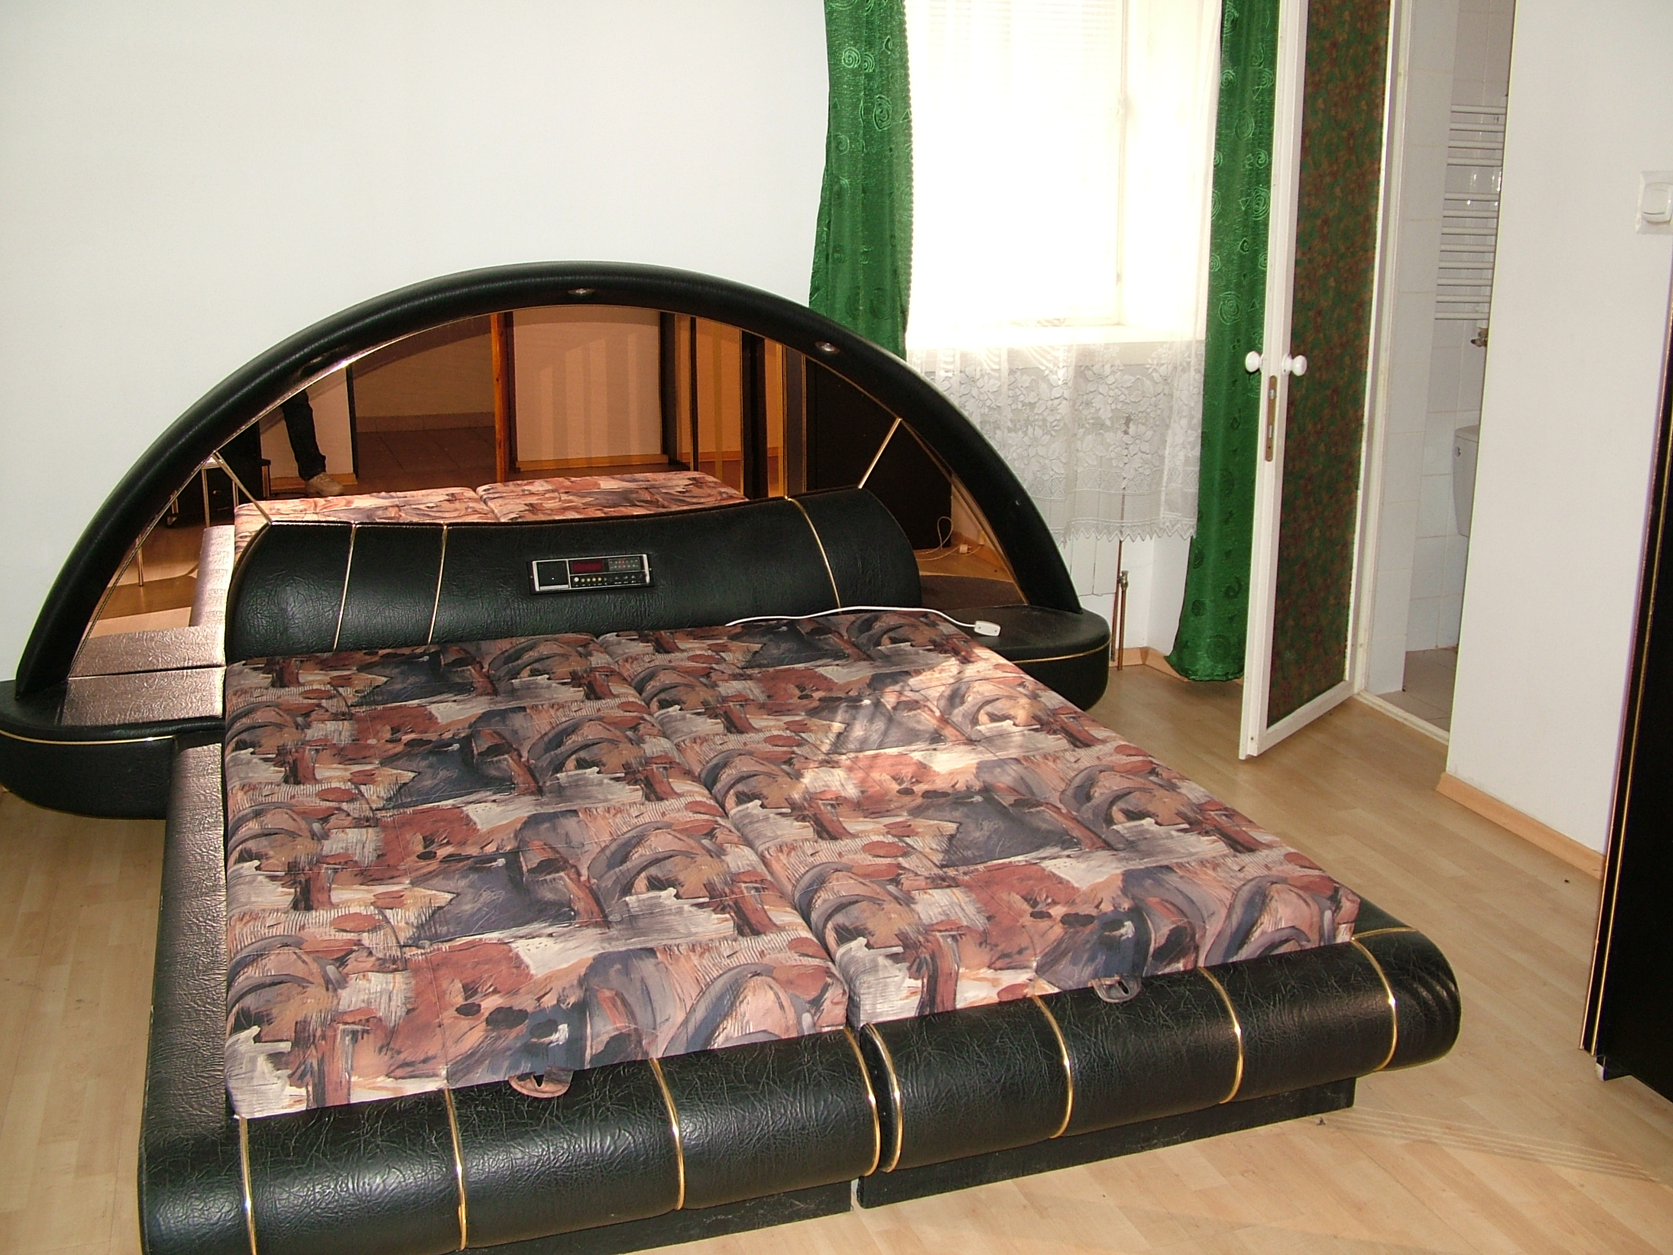 |  |  | 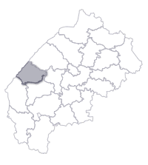
Address | Area | General information | Contact person
Sudowa Wysznia city, Mostyskyj District | 1137 m² | Possibility of usage for hotels. The condition of the investment realization is common company creation, collective form of property, distance to Lvov – 35 km, distance to railway 7 km, is located by the Lvov –Szegini road. | Jurij Turczyn – Director of the Hotel „Intur” Limited Liability Company  +38 03234 3 51 34

Investment offer 10- electrical-heating headquarter
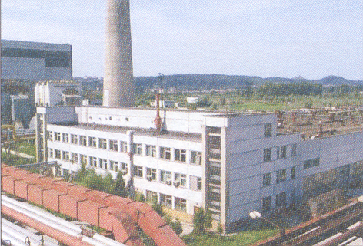
Address | Area | General information | Contact person
Murowane city, Pustomytiwski District | 19074 m² | Possibility of object’s usage: heating-electrical headquarters. The condition of the investment realization is common usage, municipal form of property, distance to Lvov – 12 km, distance to railway 1,2 km. | Igor Marczak – Director of the Lvov Municipal Company „Lwiwtepłoenergo”  +38 032 267 31 31  lte@base..lte.lviv.ua

